|  |  |  |  |
| --- | --- | --- | --- |
|  | Bansilal Ramnath Agarwal Charitable Trust's  Vishwakarma Institute of Information Technology  **Department of**  **Artificial Intelligence and Data Science** | | |
| Name: Siddhesh Dilip Khairnar | | | |
| Class: SY | Division: B | | Roll No: 272028 |
| Semester: III | | Academic Year: 2022-2023 | |
| Subject Name & Code: Data Structure, ADUA21202 | | | |
| Title of Assignment:Perform implementation of Queue using array and Linked List  Enqueue, Dequeue | | | |

**Assignment No.- 7**

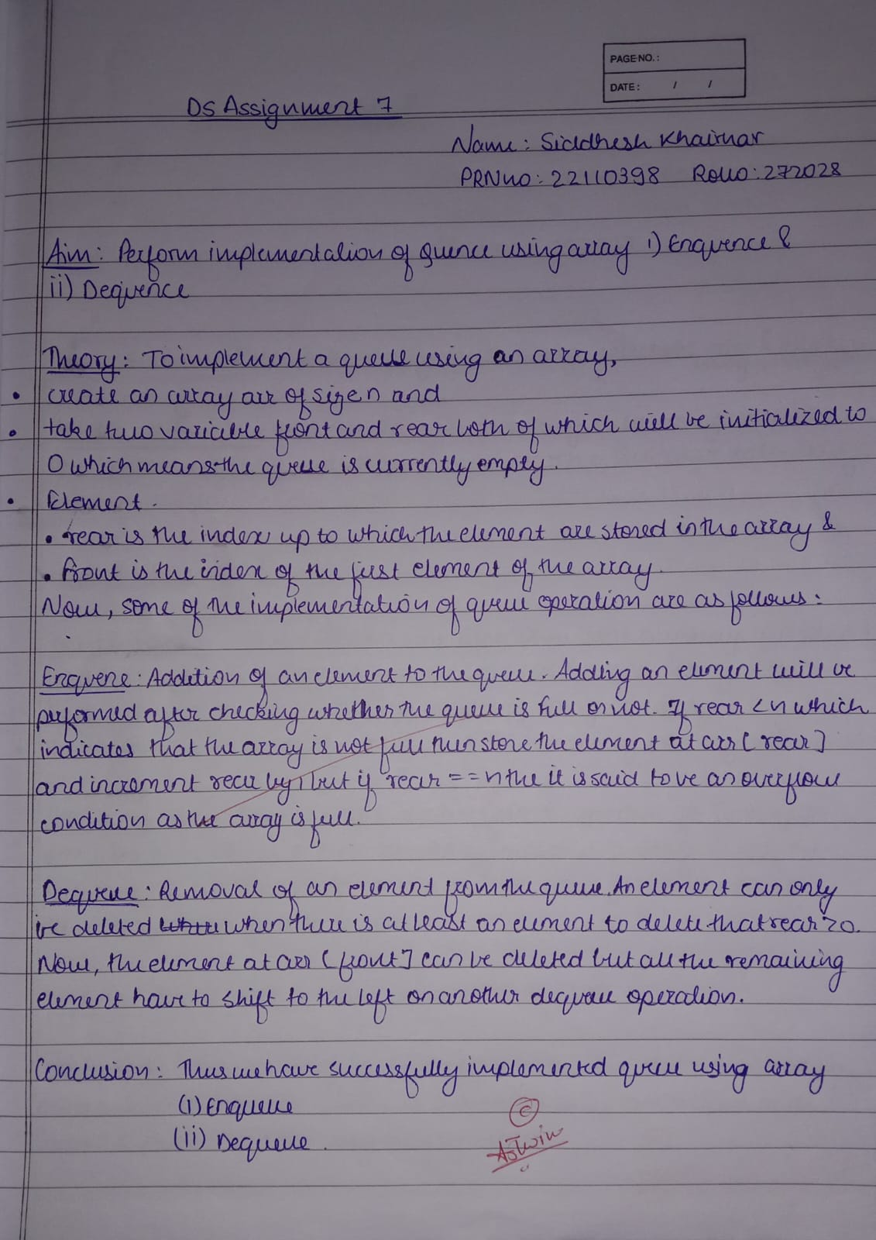

**Program:**

#include <stdio.h>

#include <stdlib.h>

struct node

{

    int info;

    struct node *ptr;

}*front,*rear,*temp,*front1;

int frontelement();

void enq(int data);

void deq();

void empty();

void display();

void create();

void queuesize();

int count = 0;

int main()

{

    int no, ch, e;

    printf("\n 1 - Enque");

    printf("\n 2 - Deque");

    printf("\n 3 - Front element");

    printf("\n 4 - Empty");

    printf("\n 5 - Exit");

    printf("\n 6 - Display");

    printf("\n 7 - Queue size");

    create();

    while (1)

    {

        printf("\n Enter choice : ");

        scanf("%d", &ch);

        switch (ch)

{

        case 1:

            printf("Enter data : ");

            scanf("%d", &no);

            enq(no);

            break;

        case 2:

            deq();

            break;

        case 3:

            e = frontelement();

            if (e != 0)

                printf("Front element : %d", e);

            else

                printf("\n No front element in Queue as queue is empty");

            break;

        case 4:

            empty();

            break;

        case 5:

            exit(0);

        case 6:

            display();

            break;

        case 7:

            queuesize();

            break;

        default:

            printf("Wrong choice, Please enter correct choice  ");

            break;

        }

    }

    return 0;

}

/* Create an empty queue */

void create()

{

    front = rear = NULL;

}

/* Returns queue size */

void queuesize()

{

    printf("\n Queue size : %d", count);

}

/* Enqueing the queue */

void enq(int data)

{

    if (rear == NULL)

    {

        rear = (struct node *)malloc(1*sizeof(struct node));

        rear->ptr = NULL;

        rear->info = data;

        front = rear;

    }

    else

    {

        temp=(struct node *)malloc(1*sizeof(struct node));

        rear->ptr = temp;

        temp->info = data;

        temp->ptr = NULL;

        rear = temp;

    }

    count++;

}

/* Displaying the queue elements */

void display()

{

    front1 = front;

    if ((front1 == NULL) && (rear == NULL))

    {

        printf("Queue is empty");

        return;

    }

    while (front1 != rear)

    {

        printf("%d ", front1->info);

        front1 = front1->ptr;

    }

    if (front1 == rear)

        printf("%d", front1->info);

}

/* Dequeing the queue */

void deq()

{

    front1 = front;

    if (front1 == NULL)

    {

        printf("\n Error: Trying to display elements from empty queue");

return;

    }

    else

        if (front1->ptr != NULL)

        {

            front1 = front1->ptr;

            printf("\n Dequed value : %d", front->info);

            free(front);

            front = front1;

        }

        else

        {

            printf("\n Dequed value : %d", front->info);

            free(front);

            front = NULL;

            rear = NULL;

        }

        count--;

}

/* Returns the front element of queue */

int frontelement()

{

    if ((front != NULL) && (rear != NULL))

        return(front->info);

    else

        return 0;

}

/* Display if queue is empty or not */

void empty()

{

     if ((front == NULL) && (rear == NULL))

        printf("\n Queue empty");

    else

       printf("Queue not empty");

}

**Output:**

